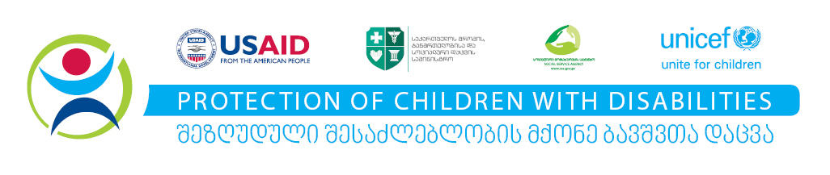

Building public-private partnerships for

protection of children with disabilities
(Location TBD), 28 September 2018

Agenda

10:00 – 10:30 Welcome coffee, registration
10:30 – 10:50 Welcome speeches:
Gottfried Hanne UNICEF Deputy Representative in Georgia
TBD USAID
Tamila Barkalaia Deputy Minister of Internally Displaced Persons from the Occupied Territories, Labor, Health and Social Affairs

10:50 – 11:30 Presenting successful example of cooperation by
- Specialized Family Type Service for children with disabilities
by Real estate company M² (and USAID/UNICEF)
- Day Care Center for Children with disabilities
by Borjomi Water Company (and Government of Bulgaria/UNICEF)
11:30 – 11:45 Presenting major challenges in child welfare reform for children with disabilities
Mari Tsereteli, department of Guardianship and Care, Social Service Agency
11:45 –12:00 Presenting public private partnership opportunities and current needs for the development of state services
Nino Odisharia, Head of Social Policy Department, Ministry of Labor, Health and Social Affairs
12:00– 12:30 Discussion
12:30– 13:30 Refreshments

